**Primera pasada**. (no hay video)

Se manda comando “com_send_cmd 7 rpi_system 10 libcamera-vid --width 320 --height 180 -n -t 5000 -o /home/pi/**video-att5.mp4**” en el tiempo unix **1693838925**

Se manda comando “com_send_cmd 7 rpi_system 10 libcamera-vid --width 160 --height 90 -n -t 10000 -o /home/pi/**video-att6.mp4**” en el tiempo unix **1693838934**

**ANEXO primera pasada.** Archivo de la actividad “**S3-040923-temp y ls.txt**” guardado en el desktop de la GS:

INP: S 7, D 10, Dp 14, Sp 43, Pr 2, Fl 0x00, Sz 200 VIA: KISS

[REMOT][1693838920][Communications] [7][0]

20.7

INP: S 12, D 10, Dp 10, Sp 22, Pr 2, Fl 0x00, Sz 31 VIA: ZMQHUB

INP: S 12, D 10, Dp 10, Sp 22, Pr 2, Fl 0x00, Sz 31 VIA: ZMQHUB

OUT: S 10, D 12, Dp 22, Sp 10, Pr 2, Fl 0x00, Sz 1 VIA: ZMQHUB

[INFO ][1693838922][Communications] TC: com_set_config 1 freq 437255124

INP: S 13, D 10, Dp 12, Sp 58, Pr 2, Fl 0x00, Sz 20 VIA: ZMQHUB

OUT: S 10, D 12, Dp 22, Sp 10, Pr 2, Fl 0x00, Sz 1 VIA: ZMQHUB

[INFO ][1693838923][Communications] TC: com_set_config 5 freq 437244876

[INFO ][1693838923][Executer] Running the command: com_set_config...

OUT: S 10, D 29, Dp 7, Sp 40, Pr 1, Fl 0x01, Sz 16 VIA: KISS

INP: S 29, D 10, Dp 40, Sp 7, Pr 1, Fl 0x01, Sz 5 VIA: KISS

[RES ][1693838923][cmdAX100] Param freq (table 1) set to: U32 437255124

[INFO ][1693838923][Executer] Command result: 1

OUT: S 10, D 13, Dp 58, Sp 12, Pr 2, Fl 0x00, Sz 1 VIA: ZMQHUB

[INFO ][1693838923][Executer] Running the command: com_set_config...

OUT: S 10, D 29, Dp 7, Sp 41, Pr 1, Fl 0x01, Sz 16 VIA: KISS

INP: S 29, D 10, Dp 41, Sp 7, Pr 1, Fl 0x01, Sz 5 VIA: KISS

[RES ][1693838923][cmdAX100] Param freq (table 5) set to: U32 437244876

[INFO ][1693838923][Executer] Command result: 1

[INFO ][1693838923][Executer] Running the command: com_set_time_node...

[INFO ][1693838923][cmdCOM] Sending command 'com_send_cmd 7 obc_set_time 1693838923' to 7

OUT: S 10, D 7, Dp 10, Sp 42, Pr 1, Fl 0x00, Sz 23 VIA: KISS

INP: S 7, D 10, Dp 42, Sp 10, Pr 1, Fl 0x00, Sz 1 VIA: KISS

[INFO ][1693838924][Executer] Command result: 1

INP: S 13, D 10, Dp 12, Sp 60, Pr 2, Fl 0x00, Sz 106 VIA: ZMQHUB

OUT: S 10, D 13, Dp 60, Sp 12, Pr 2, Fl 0x00, Sz 1 VIA: ZMQHUB

[INFO ][1693838925][Executer] Running the command: com_send_cmd...

OUT: S 10, D 7, Dp 10, Sp 43, Pr 1, Fl 0x00, Sz 91 VIA: KISS

INP: S 7, D 10, Dp 43, Sp 10, Pr 1, Fl 0x00, Sz 1 VIA: KISS

[INFO ][1693838926][Executer] Command result: 1

INP: S 12, D 10, Dp 10, Sp 22, Pr 2, Fl 0x00, Sz 31 VIA: ZMQHUB

INP: S 12, D 10, Dp 10, Sp 22, Pr 2, Fl 0x00, Sz 31 VIA: ZMQHUB

OUT: S 10, D 12, Dp 22, Sp 10, Pr 2, Fl 0x00, Sz 1 VIA: ZMQHUB

[INFO ][1693838927][Communications] TC: com_set_config 1 freq 437254844

OUT: S 10, D 12, Dp 22, Sp 10, Pr 2, Fl 0x00, Sz 1 VIA: ZMQHUB

[INFO ][1693838927][Communications] TC: com_set_config 5 freq 437245156

[INFO ][1693838927][Executer] Running the command: com_set_config...

OUT: S 10, D 29, Dp 7, Sp 44, Pr 1, Fl 0x01, Sz 16 VIA: KISS

INP: S 29, D 10, Dp 44, Sp 7, Pr 1, Fl 0x01, Sz 5 VIA: KISS

[RES ][1693838927][cmdAX100] Param freq (table 1) set to: U32 437254844

[INFO ][1693838927][Executer] Command result: 1

[INFO ][1693838927][Executer] Running the command: com_set_config...

OUT: S 10, D 29, Dp 7, Sp 45, Pr 1, Fl 0x01, Sz 16 VIA: KISS

INP: S 29, D 10, Dp 45, Sp 7, Pr 1, Fl 0x01, Sz 5 VIA: KISS

[RES ][1693838927][cmdAX100] Param freq (table 5) set to: U32 437245156

[INFO ][1693838927][Executer] Command result: 1

INP: S 12, D 10, Dp 10, Sp 22, Pr 2, Fl 0x00, Sz 31 VIA: ZMQHUB

INP: S 12, D 10, Dp 10, Sp 22, Pr 2, Fl 0x00, Sz 31 VIA: ZMQHUB

OUT: S 10, D 12, Dp 22, Sp 10, Pr 2, Fl 0x00, Sz 1 VIA: ZMQHUB

[INFO ][1693838932][Communications] TC: com_set_config 1 freq 437254533

OUT: S 10, D 12, Dp 22, Sp 10, Pr 2, Fl 0x00, Sz 1 VIA: ZMQHUB

[INFO ][1693838932][Communications] TC: com_set_config 5 freq 437245467

[INFO ][1693838932][Executer] Running the command: com_set_config...

OUT: S 10, D 29, Dp 7, Sp 46, Pr 1, Fl 0x01, Sz 16 VIA: KISS

INP: S 29, D 10, Dp 46, Sp 7, Pr 1, Fl 0x01, Sz 5 VIA: KISS

[RES ][1693838932][cmdAX100] Param freq (table 1) set to: U32 437254533

[INFO ][1693838932][Executer] Command result: 1

[INFO ][1693838932][Executer] Running the command: com_set_config...

OUT: S 10, D 29, Dp 7, Sp 47, Pr 1, Fl 0x01, Sz 16 VIA: KISS

INP: S 29, D 10, Dp 47, Sp 7, Pr 1, Fl 0x01, Sz 5 VIA: KISS

[RES ][1693838932][cmdAX100] Param freq (table 5) set to: U32 437245467

[INFO ][1693838932][Executer] Command result: 1

INP: S 13, D 10, Dp 12, Sp 62, Pr 2, Fl 0x00, Sz 106 VIA: ZMQHUB

OUT: S 10, D 13, Dp 62, Sp 12, Pr 2, Fl 0x00, Sz 1 VIA: ZMQHUB

[INFO ][1693838934][Executer] Running the command: com_send_cmd...

OUT: S 10, D 7, Dp 10, Sp 48, Pr 1, Fl 0x00, Sz 91 VIA: KISS

INP: S 7, D 10, Dp 48, Sp 10, Pr 1, Fl 0x00, Sz 1 VIA: KISS

[INFO ][1693838935][Executer] Command result: 1

INP: S 12, D 10, Dp 10, Sp 22, Pr 2, Fl 0x00, Sz 31 VIA: ZMQHUB

INP: S 12, D 10, Dp 10, Sp 22, Pr 2, Fl 0x00, Sz 31 VIA: ZMQHUB

OUT: S 10, D 12, Dp 22, Sp 10, Pr 2, Fl 0x00, Sz 1 VIA: ZMQHUB

[INFO ][1693838937][Communications] TC: com_set_config 1 freq 437254207

INP: S 7, D 10, Dp 14, Sp 44, Pr 2, Fl 0x00, Sz 200 VIA: KISS

[REMOT][1693838954][Communications] [7][1024]

-rw-r--r-- 1 pi pi 39K Aug 24 17:19 /home/pi/video-att4.mp4

-rw-r--r-- 1 pi pi 266K Sep 4 15:48 /home/pi/video-att5.mp4

-rw-r--r-- 1 pi pi 247K Sep 4 15:49 /home/pi/video-att6.mp4

**Segunda Pasada**

Se manda commando “com_send_cmd 7 rpi_system 10 libcamera-vid --width 320 --height 180 -n -t 5000 -o /home/pi/**video-att7.mp4**” en el tiempo unix **1693844476**

Después se envía varias veces el comando “com_send_cmd 7 rpi_system 10 libcamera-vid --width 160 --height 90 -n -t 10000 -o /home/pi/**video-att8.mp4**” pero responde 0 y al verificar con ls (ver anexo) no está el archivo **video-att8.mp4.**

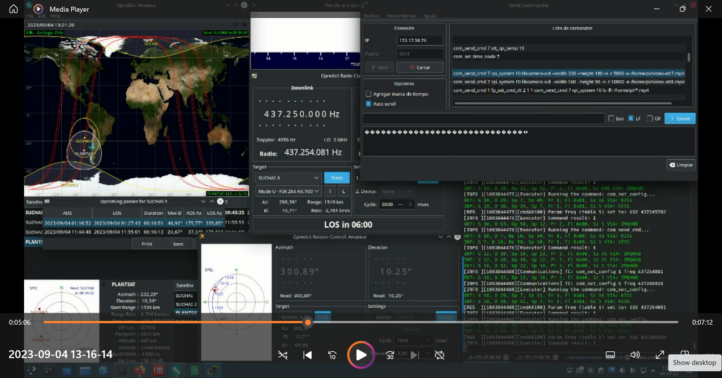

Pero se manda commando “com_send_cmd 7 rpi_system 10 libcamera-vid --width 160 --height 90 -n -t 10000 -o /home/pi/**video-att9.mp4**” en el tiempo unix **1693844549,** y aunque no hubo confirmación de envío correcto, no hubo error de envío y se confirmó con ls que se creo el archivo “**video-att9.mp4**”.

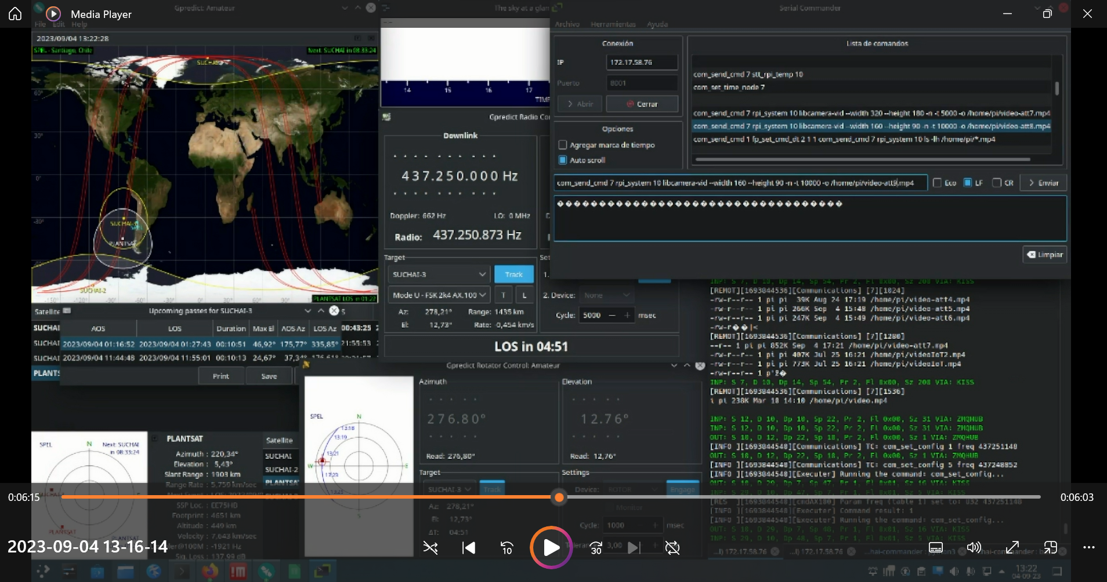

Se envía comando ls para verificar que esta el archivo “**video-att9.mp4**” (ver anexo segunda pasada)

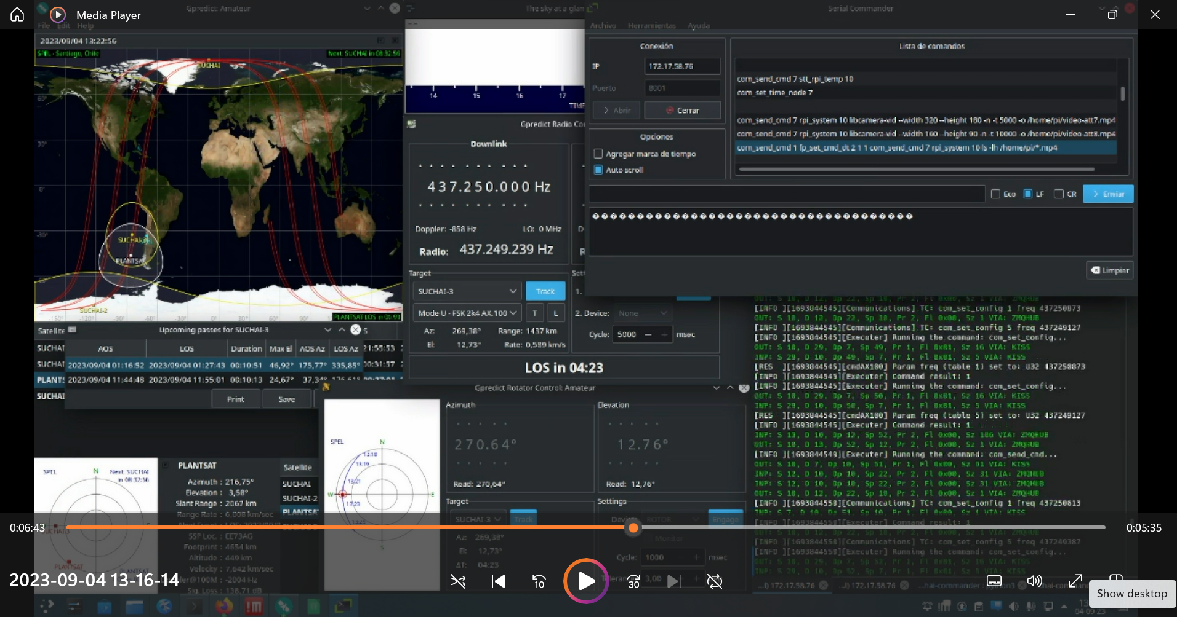

**ANEXO segunda pasada.** Archivo de la actividad “**S3-040923-temp y ls2.txt**” guardado en el desktop de la GS:

[INFO ][1693844455][Executer] Command result: 1

INP: S 7, D 10, Dp 14, Sp 50, Pr 2, Fl 0x00, Sz 200 VIA: KISS

[REMOT][1693844456][Communications] [7][0]

30.4

INP: S 13, D 10, Dp 12, Sp 56, Pr 2, Fl 0x00, Sz 20 VIA: ZMQHUB

OUT: S 10, D 13, Dp 56, Sp 12, Pr 2, Fl 0x00, Sz 1 VIA: ZMQHUB

[INFO ][1693844458][Executer] Running the command: com_set_time_node...

[INFO ][1693844458][cmdCOM] Sending command 'com_send_cmd 7 obc_set_time 1693844458' to 7

OUT: S 10, D 7, Dp 10, Sp 41, Pr 1, Fl 0x00, Sz 23 VIA: KISS

INP: S 7, D 10, Dp 41, Sp 10, Pr 1, Fl 0x00, Sz 1 VIA: KISS

[INFO ][1693844458][Executer] Command result: 1

INP: S 12, D 10, Dp 10, Sp 22, Pr 2, Fl 0x00, Sz 31 VIA: ZMQHUB

INP: S 13, D 10, Dp 12, Sp 58, Pr 2, Fl 0x00, Sz 106 VIA: ZMQHUB

[INFO ][1693844475][Executer] Running the command: com_set_config...

OUT: S 10, D 29, Dp 7, Sp 49, Pr 1, Fl 0x01, Sz 16 VIA: KISS

INP: S 29, D 10, Dp 49, Sp 7, Pr 1, Fl 0x01, Sz 5 VIA: KISS

[RES ][1693844475][cmdAX100] Param freq (table 5) set to: U32 437245702

[INFO ][1693844475][Executer] Command result: 1

OUT: S 10, D 13, Dp 58, Sp 12, Pr 2, Fl 0x00, Sz 1 VIA: ZMQHUB

[INFO ][1693844476][Executer] Running the command: com_send_cmd...

OUT: S 10, D 7, Dp 10, Sp 50, Pr 1, Fl 0x00, Sz 91 VIA: KISS

INP: S 7, D 10, Dp 50, Sp 10, Pr 1, Fl 0x00, Sz 1 VIA: KISS

[INFO ][1693844476][Executer] Command result: 1

INP: S 12, D 10, Dp 10, Sp 22, Pr 2, Fl 0x00, Sz 31 VIA: ZMQHUB

INP: S 12, D 10, Dp 10, Sp 22, Pr 2, Fl 0x00, Sz 31 VIA: ZMQHUB

OUT: S 10, D 12, Dp 22, Sp 10, Pr 2, Fl 0x00, Sz 1 VIA: ZMQHUB

[INFO ][1693844480][Communications] TC: com_set_config 1 freq 437254081

OUT: S 10, D 12, Dp 22, Sp 10, Pr 2, Fl 0x00, Sz 1 VIA: ZMQHUB

[INFO ][1693844480][Communications] TC: com_set_config 5 freq 437245919

[INFO ][1693844480][Executer] Running the command: com_set_config...

OUT: S 10, D 29, Dp 7, Sp 51, Pr 1, Fl 0x01, Sz 16 VIA: KISS

INP: S 29, D 10, Dp 51, Sp 7, Pr 1, Fl 0x01, Sz 5 VIA: KISS

[RES ][1693844480][cmdAX100] Param freq (table 1) set to: U32 437254081

[INFO ][1693844480][Executer] Command result: 1

[INFO ][1693844480][Executer] Running the command: com_set_config...

OUT: S 10, D 29, Dp 7, Sp 52, Pr 1, Fl 0x01, Sz 16 VIA: KISS

INP: S 29, D 10, Dp 52, Sp 7, Pr 1, Fl 0x01, Sz 5 VIA: KISS

[RES ][1693844480][cmdAX100] Param freq (table 5) set to: U32 437245919

[INFO ][1693844480][Executer] Command result: 1

INP: S 12, D 10, Dp 10, Sp 22, Pr 2, Fl 0x00, Sz 31 VIA: ZMQHUB

INP: S 12, D 10, Dp 10, Sp 22, Pr 2, Fl 0x00, Sz 31 VIA: ZMQHUB

INP: S 13, D 10, Dp 12, Sp 60, Pr 2, Fl 0x00, Sz 106 VIA: ZMQHUB

OUT: S 10, D 12, Dp 22, Sp 10, Pr 2, Fl 0x00, Sz 1 VIA: ZMQHUB

[INFO ][1693844485][Communications] TC: com_set_config 1 freq 437253872

OUT: S 10, D 12, Dp 22, Sp 10, Pr 2, Fl 0x00, Sz 1 VIA: ZMQHUB

[INFO ][1693844485][Communications] TC: com_set_config 5 freq 437246128

[INFO ][1693844485][Executer] Running the command: com_set_config...

OUT: S 10, D 29, Dp 7, Sp 53, Pr 1, Fl 0x01, Sz 16 VIA: KISS

INP: S 29, D 10, Dp 53, Sp 7, Pr 1, Fl 0x01, Sz 5 VIA: KISS

[RES ][1693844485][cmdAX100] Param freq (table 1) set to: U32 437253872

[INFO ][1693844485][Executer] Command result: 1

OUT: S 10, D 13, Dp 60, Sp 12, Pr 2, Fl 0x00, Sz 1 VIA: ZMQHUB

[INFO ][1693844486][Executer] Running the command: com_set_config...

OUT: S 10, D 29, Dp 7, Sp 54, Pr 1, Fl 0x01, Sz 16 VIA: KISS

INP: S 29, D 10, Dp 54, Sp 7, Pr 1, Fl 0x01, Sz 5 VIA: KISS

[RES ][1693844486][cmdAX100] Param freq (table 5) set to: U32 437246128

[INFO ][1693844486][Executer] Command result: 1

[INFO ][1693844486][Executer] Running the command: com_send_cmd...

OUT: S 10, D 7, Dp 10, Sp 55, Pr 1, Fl 0x00, Sz 91 VIA: KISS

[ERROR][1693844487][cmdCOM] Error sending command. (rc: 0, re: 0)

[INFO ][1693844487][Executer] Command result: 0

INP: S 12, D 10, Dp 10, Sp 22, Pr 2, Fl 0x00, Sz 31 VIA: ZMQHUB

INP: S 12, D 10, Dp 10, Sp 22, Pr 2, Fl 0x00, Sz 31 VIA: ZMQHUB

OUT: S 10, D 12, Dp 22, Sp 10, Pr 2, Fl 0x00, Sz 1 VIA: ZMQHUB

[INFO ][1693844490][Communications] TC: com_set_config 1 freq 437253644

OUT: S 10, D 12, Dp 22, Sp 10, Pr 2, Fl 0x00, Sz 1 VIA: ZMQHUB

INP: S 13, D 10, Dp 12, Sp 52, Pr 2, Fl 0x00, Sz 106 VIA: ZMQHUB

OUT: S 10, D 13, Dp 52, Sp 12, Pr 2, Fl 0x00, Sz 1 VIA: ZMQHUB

[INFO ][1693844549][Executer] Running the command: com_send_cmd...

OUT: S 10, D 7, Dp 10, Sp 51, Pr 1, Fl 0x00, Sz 91 VIA: KISS

INP: S 12, D 10, Dp 10, Sp 22, Pr 2, Fl 0x00, Sz 31 VIA: ZMQHUB

INP: S 12, D 10, Dp 10, Sp 22, Pr 2, Fl 0x00, Sz 31 VIA: ZMQHUB

OUT: S 10, D 12, Dp 22, Sp 10, Pr 2, Fl 0x00, Sz 1 VIA: ZMQHUB

[INFO ][1693844550][Communications] TC: com_set_config 1 freq 437250613

INP: S 7, D 10, Dp 51, Sp 10, Pr 1, Fl 0x00, Sz 1 VIA: KISS

[INFO ][1693844550][Executer] Command result: 1

OUT: S 10, D 12, Dp 22, Sp 10, Pr 2, Fl 0x00, Sz 1 VIA: ZMQHUB

OUT: S 10, D 29, Dp 7, Sp 32, Pr 1, Fl 0x01, Sz 16 VIA: KISS

INP: S 29, D 10, Dp 32, Sp 7, Pr 1, Fl 0x01, Sz 5 VIA: KISS

[RES ][1693844576][cmdAX100] Param freq (table 5) set to: U32 437250761

[INFO ][1693844576][Executer] Command result: 1

[REMOT][1693844576][Communications] [7][256]

pi 814K Mar 18 15:24 /home/pi/video3.mp4

-rw-r--r-- 1 pi pi 5.1K Apr 5 05:43 /home/pi/video4.mp4

-rw-r--r-- 1 pi pi 8.2K Apr 5 05:45 /home/pi/video5.mp4

-rw-r--r-- 1 pi pi 24K Apr 7 17���

INP: S 7, D 10, Dp 14, Sp 55, Pr 2, Fl 0x00, Sz 200 VIA: KISS

[REMOT][1693844576][Communications] [7][512]

:14 /home/pi/video6.mp4

-rw-r--r-- 1 pi pi 24K Apr 8 04:23 /home/pi/video7.mp4

-rw-r--r-- 1 pi pi 40K Apr 16 17:30 /home/pi/video8.mp4

-rw-r--r-- 1 pi pi 51K Apr 17 17:00 /home/pi/video/�p�

[REMOT][1693844576][Communications] [7][768]

9.mp4

-rw-r--r-- 1 pi pi 122K Aug 24 15:44 /home/pi/video-att1.mp4

-rw-r--r-- 1 pi pi 42K Aug 24 15:45 /home/pi/video-att2.mp4

-rw-r--r-- 1 pi pi 89K Aug 24 17:18 /home/pi/video-att3.mp4

�V�

INP: S 7, D 10, Dp 14, Sp 55, Pr 2, Fl 0x00, Sz 200 VIA: KISS

[REMOT][1693844576][Communications] [7][1024]

-rw-r--r-- 1 pi pi 39K Aug 24 17:19 /home/pi/video-att4.mp4

-rw-r--r-- 1 pi pi 266K Sep 4 15:48 /home/pi/video-att5.mp4

-rw-r--r-- 1 pi pi 247K Sep 4 15:49 /home/pi/video-att6.mp4

-rw-r��|<

INP: S 7, D 10, Dp 14, Sp 55, Pr 2, Fl 0x00, Sz 200 VIA: KISS

[REMOT][1693844577][Communications] [7][1280]

--r-- 1 pi pi 852K Sep 4 17:21 /home/pi/video-att7.mp4

-rw-r--r-- 1 pi pi 387K Sep 4 17:22 /home/pi/video-att9.mp4

-rw-r--r-- 1 pi pi 407K Jul 25 16:21 /home/pi/videoIoT2.mp4

-rw-r--r-- 1%�X_

INP: S 7, D 10, Dp 14, Sp 55, Pr 2, Fl 0x00, Sz 200 VIA: KISS

[REMOT][1693844577][Communications] [7][1536]

pi pi 773K Jul 25 16:21 /home/pi/videoIoT.mp4

-rw-r--r-- 1 pi pi 238K Mar 10 14:10 /home/pi/video.mp4